**Practical : 10**

# AIM : Use of R Markdown and RStudio Cloud (Store mini project in RStudio Cloud).

**Theory:** [The R Project for Statistical Computing](https://www.r-project.org/) is is a free software environment for statistical computing and graphics. Here, we will setup a [cloud solution](https://rstudio.cloud/) made available by [RStudio](https://rstudio.com/).

R is the programming language and RStudio is the IDE (Integrated Developer Environment). To understand R versus RStudio, we can make an analogy to a car. If you think of R as the engine, then RStudio is the rest of the car. I.e. RStudio allows us to interact with R in a seamless manner.

Create account in RStudio Cloud.

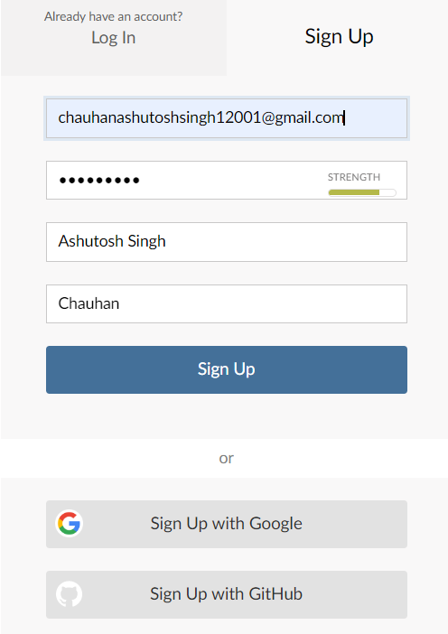

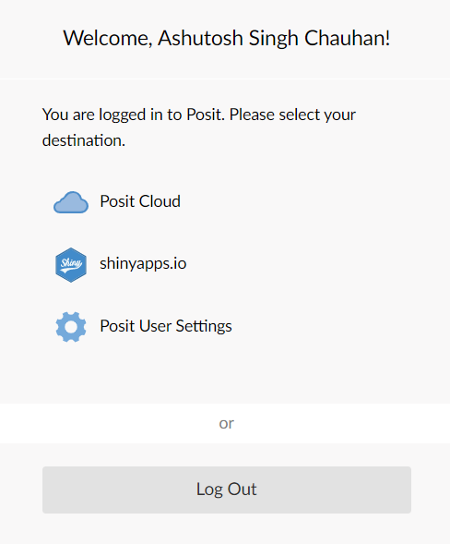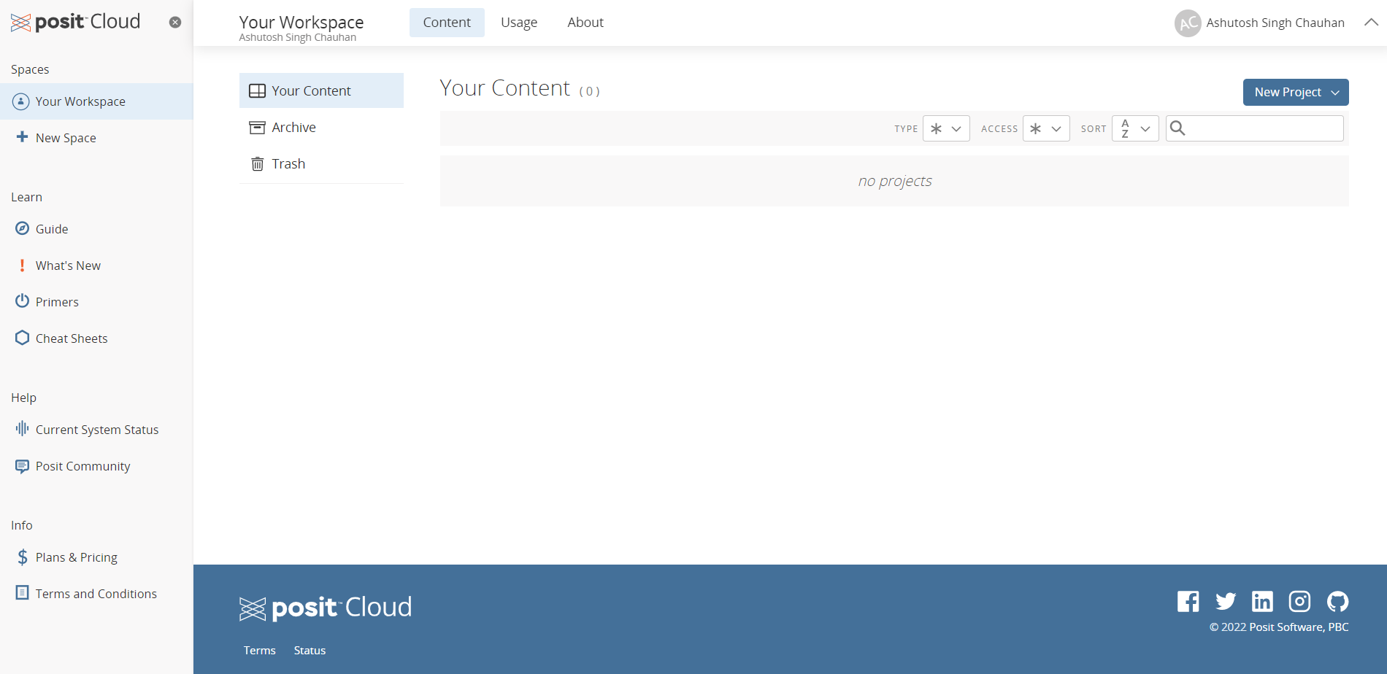

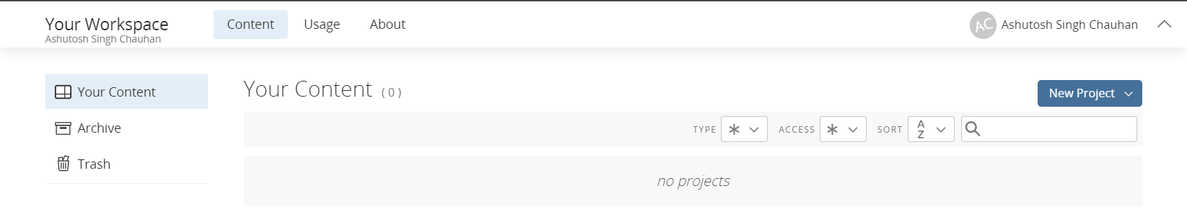

**1**. **The latest version of modEvA should be installed**

install.packages("modEvA")

2**. Make sure the package is loaded**

**> library(modEvA)**

3. Performing a model analysis

> data(rotif.mods)

> help(rotif.mods)

> names(rotif.mods$models)

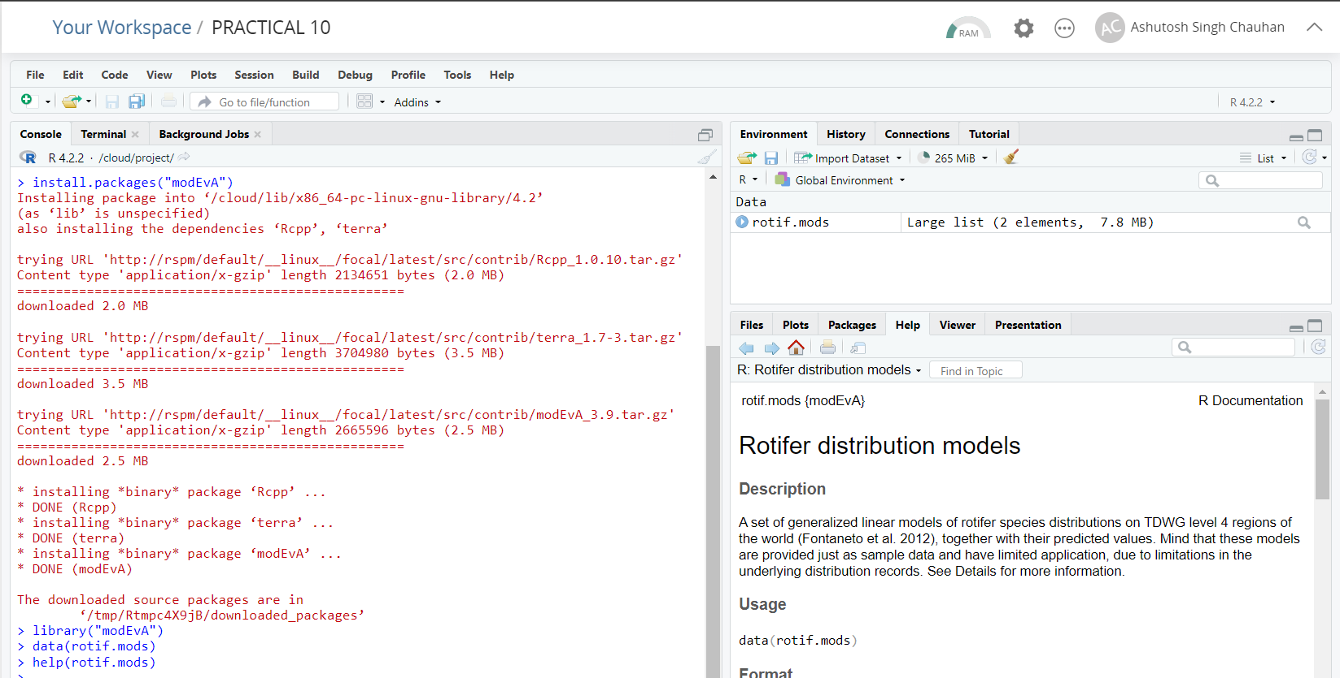

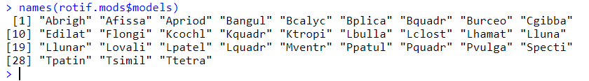

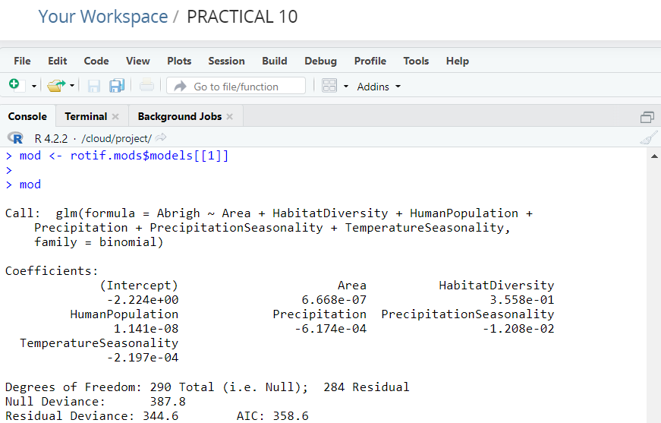

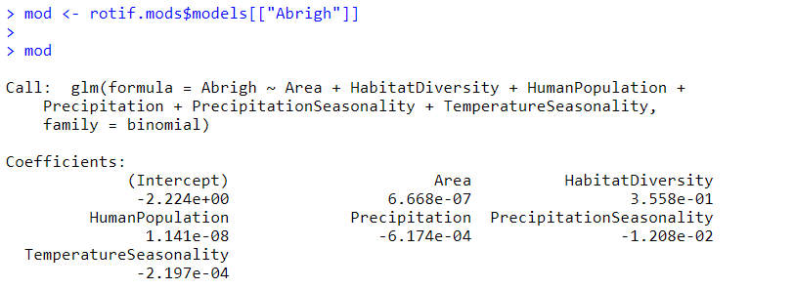

|  |
| --- |
| > mydata <- data.frame(observed = mod$y, predicted = mod$fitted.values)  > plotGLM(model = mod, xlab = "Logit (Y)", ylab = "Predicted probability", main = "Model plot") |
|  |
|  |

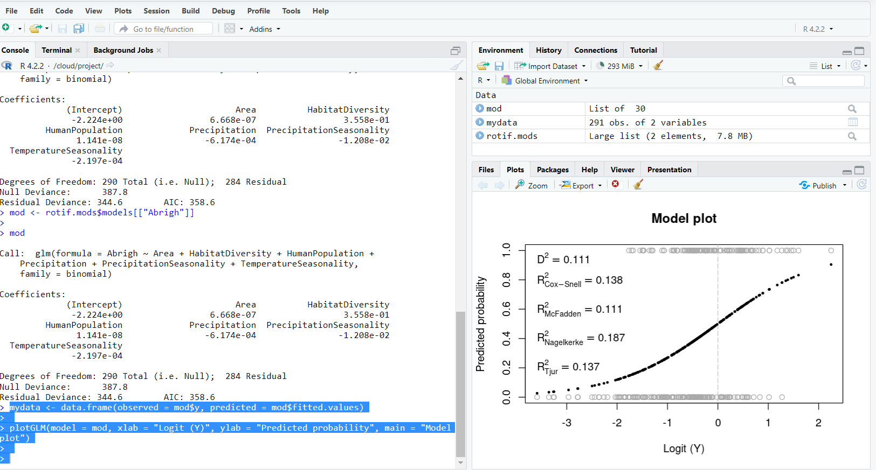

>plotGLM(obs = mydata[ , "observed"], pred = mydata[ , "predicted"], xlab = "Logit (Y)", ylab = "Predicted probability", main = "Model plot")

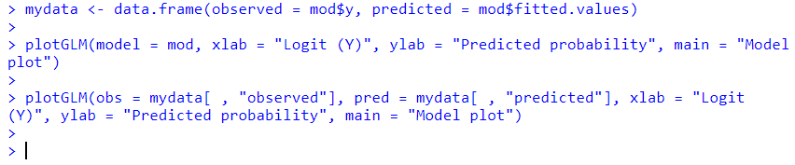

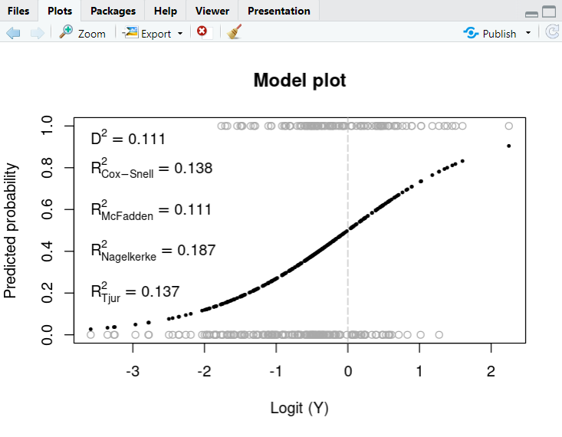

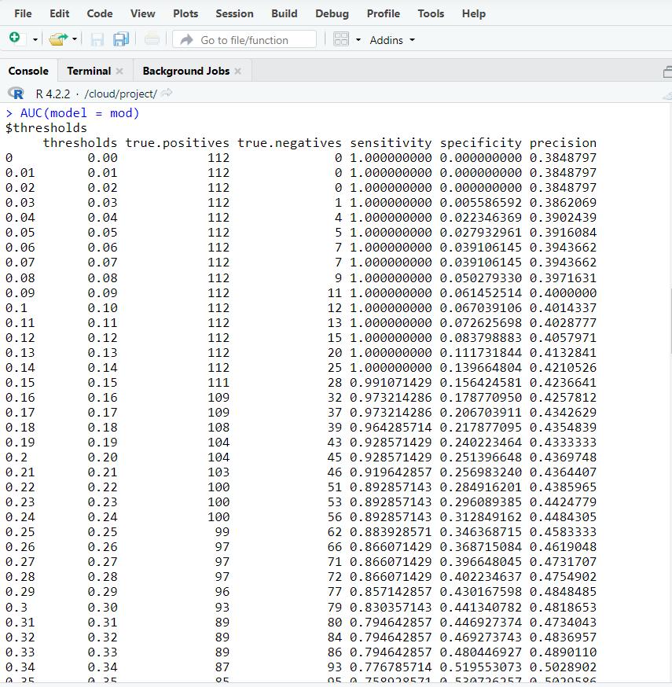

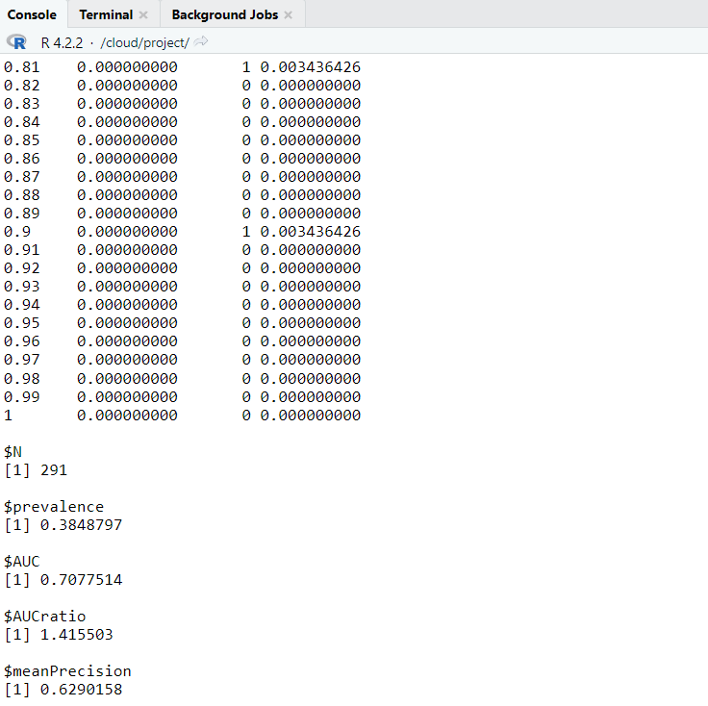 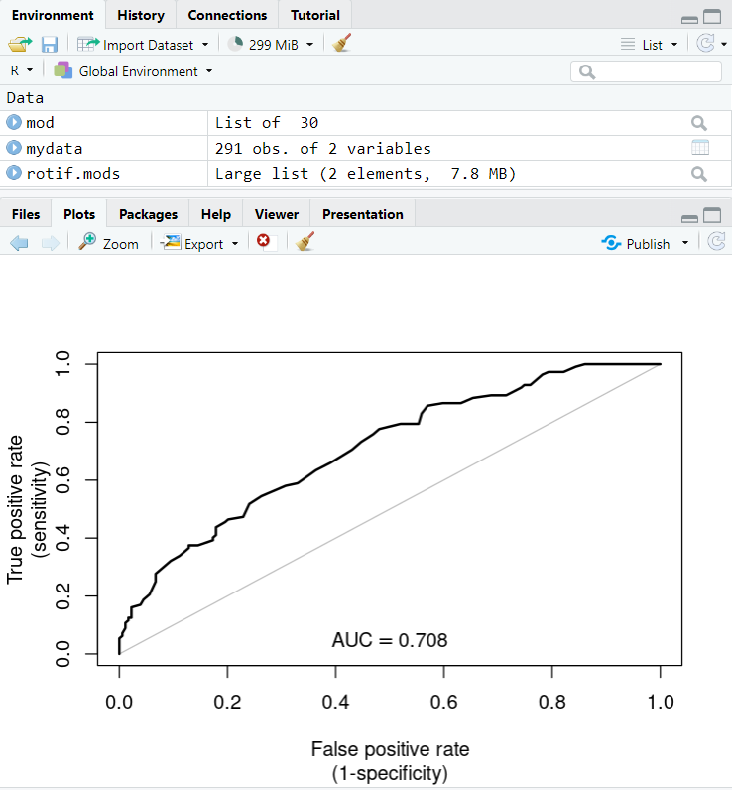

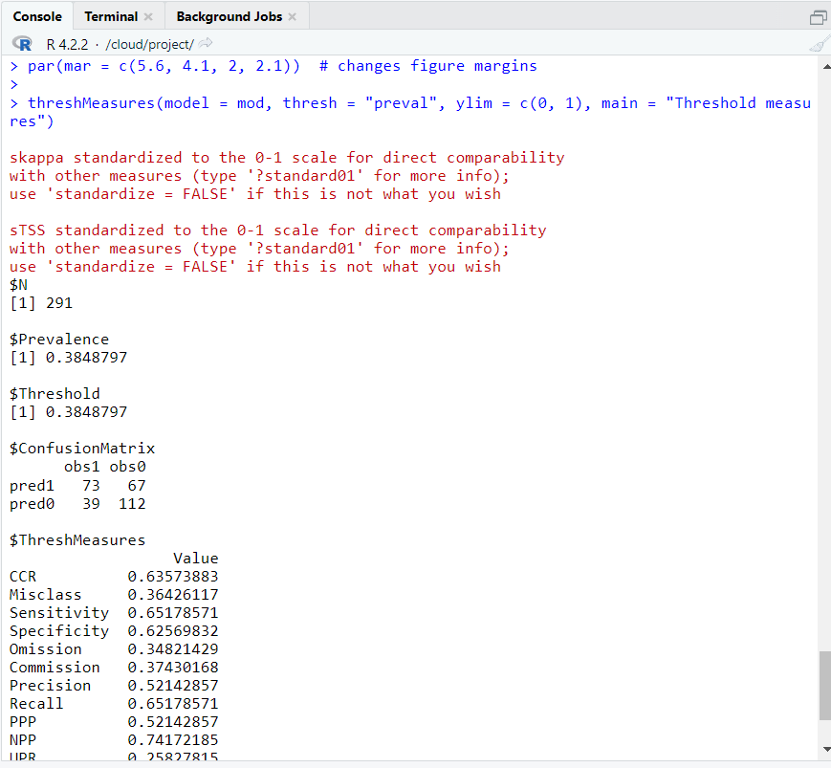 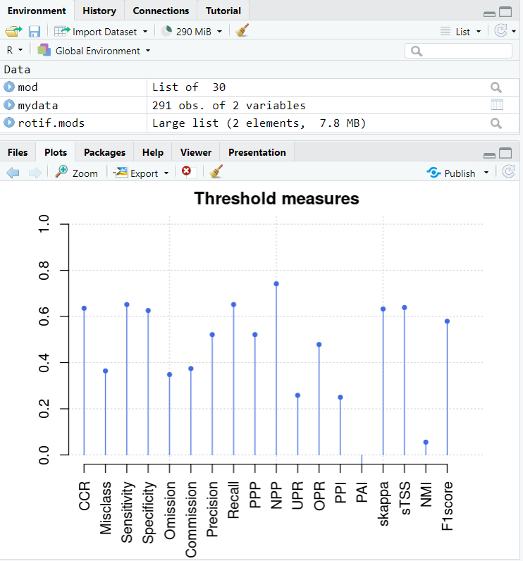

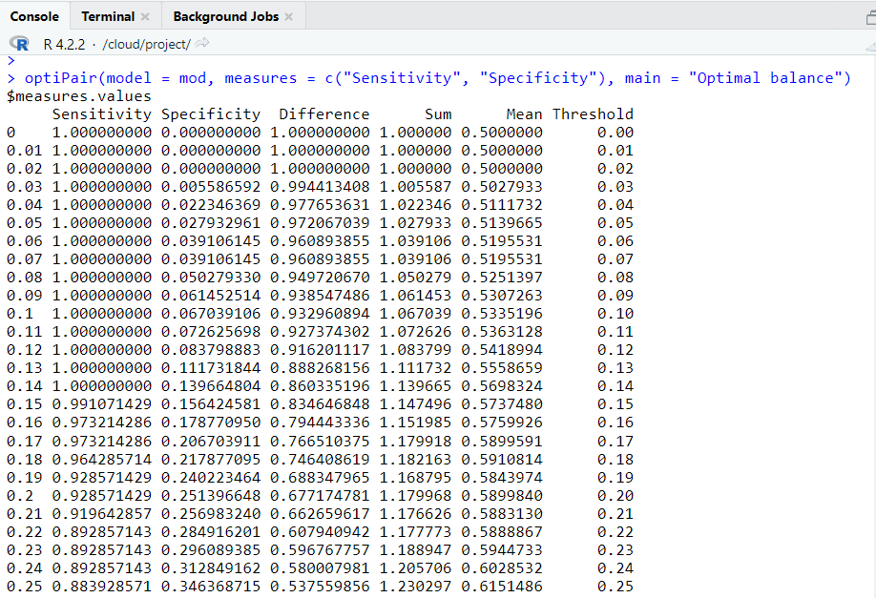 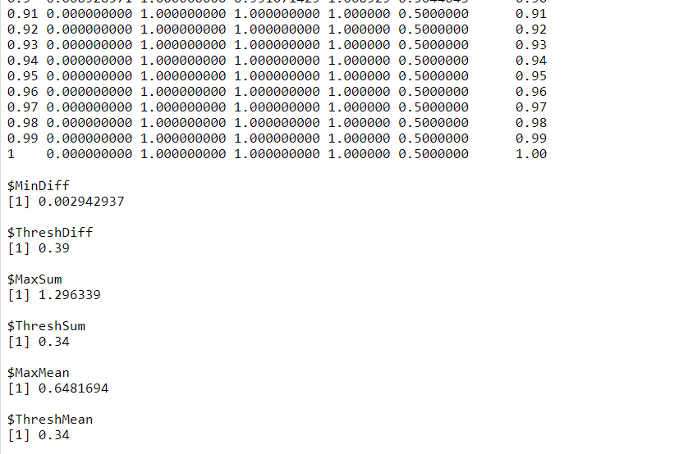

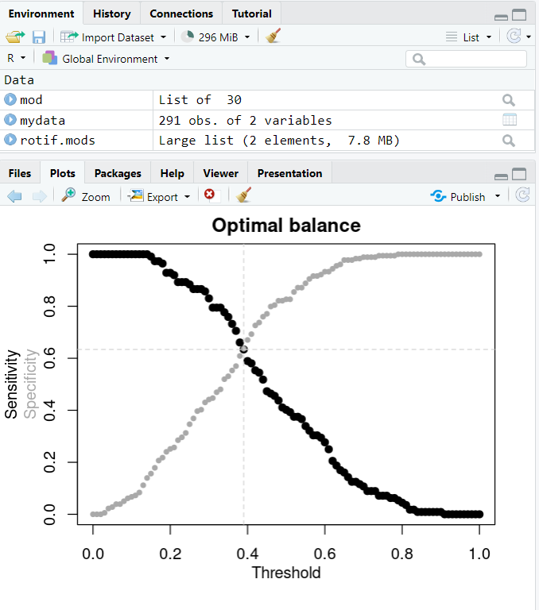 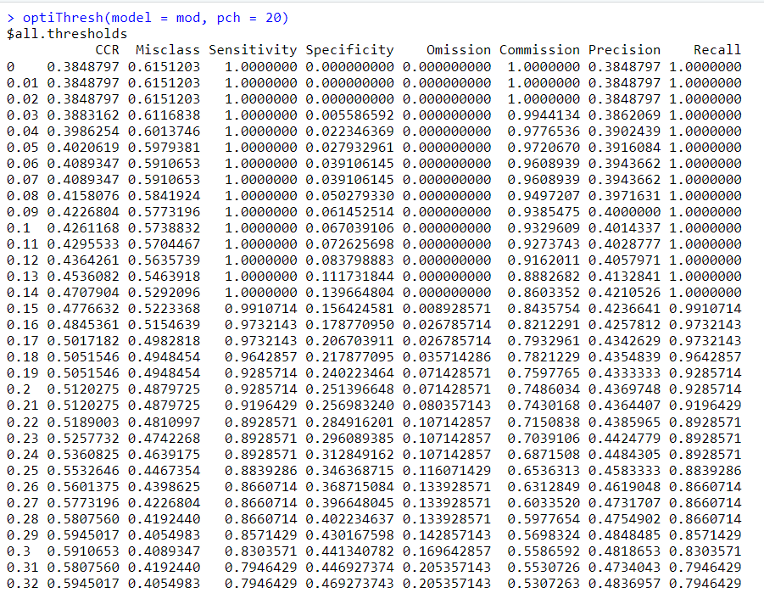

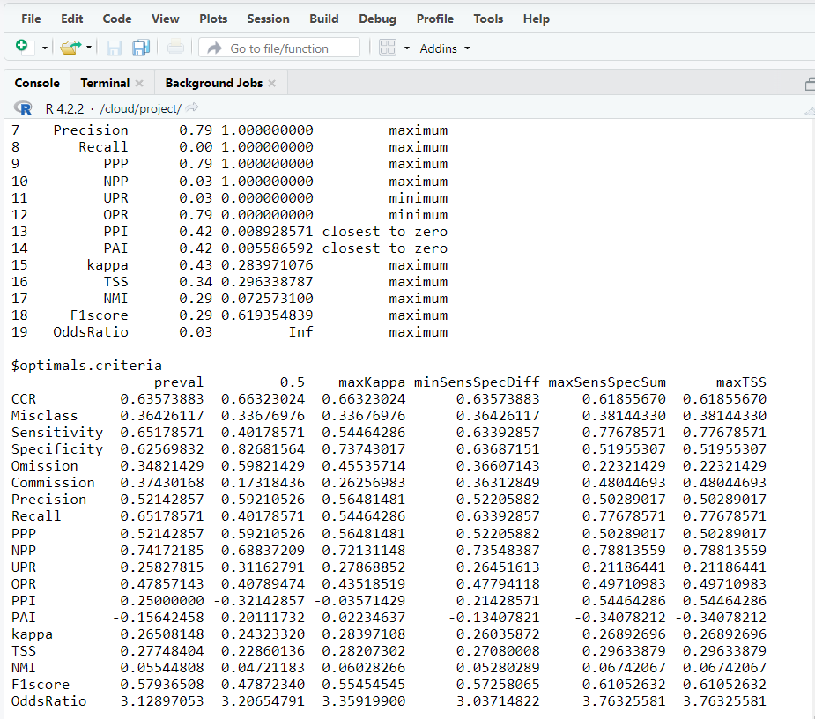

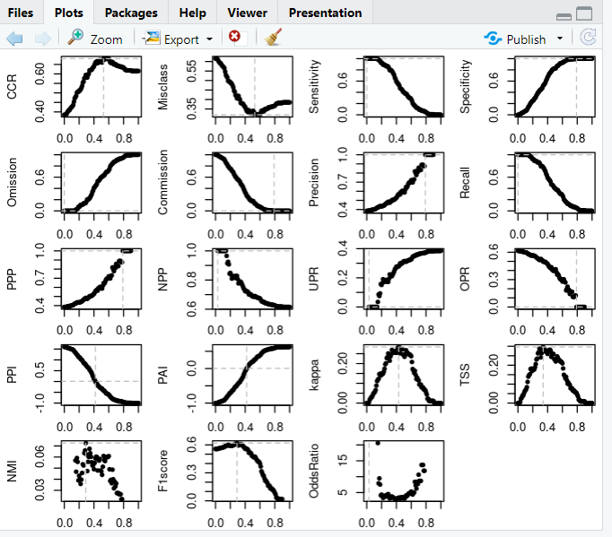

**Assessing model explanatory power, fit and calibration**

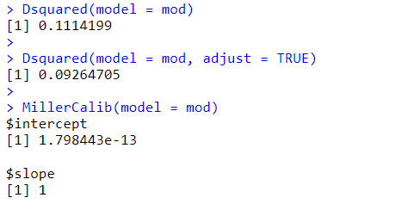 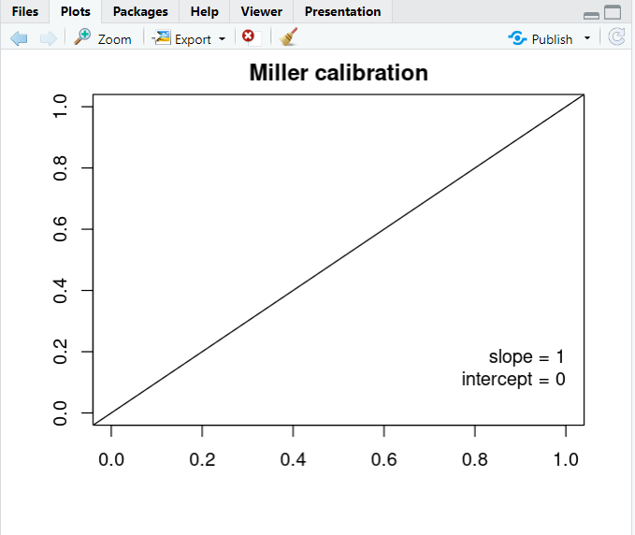

>HLfit(model = mod, bin.method = "quantiles", main = "Hosmer-Lemeshow GOF, quantiles")

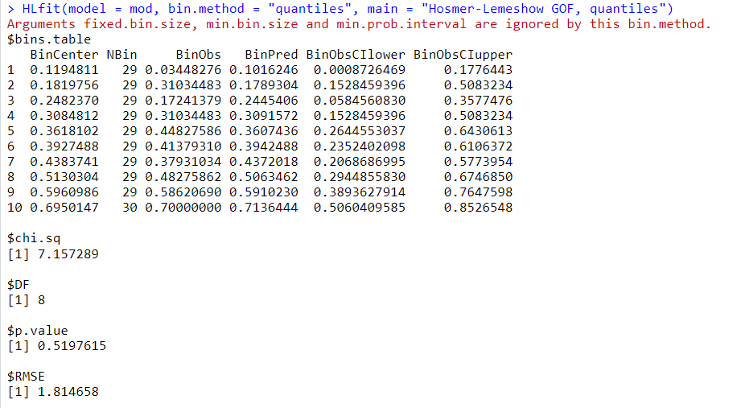 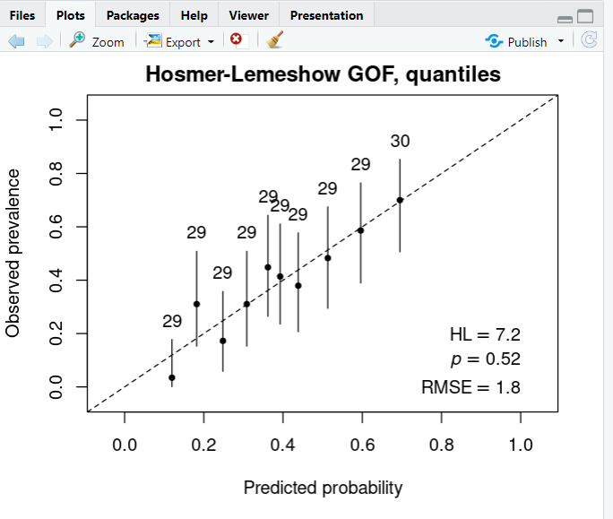

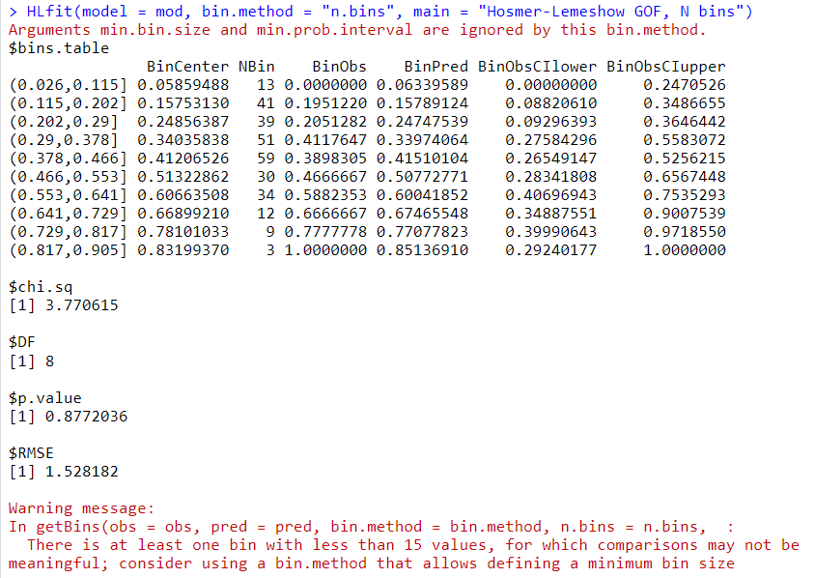 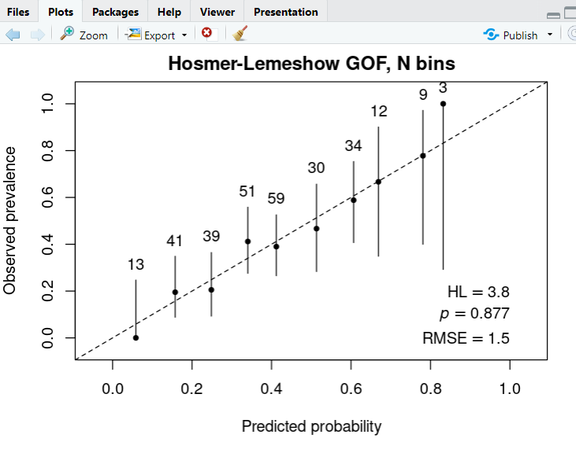

## **Evaluating multiple models**

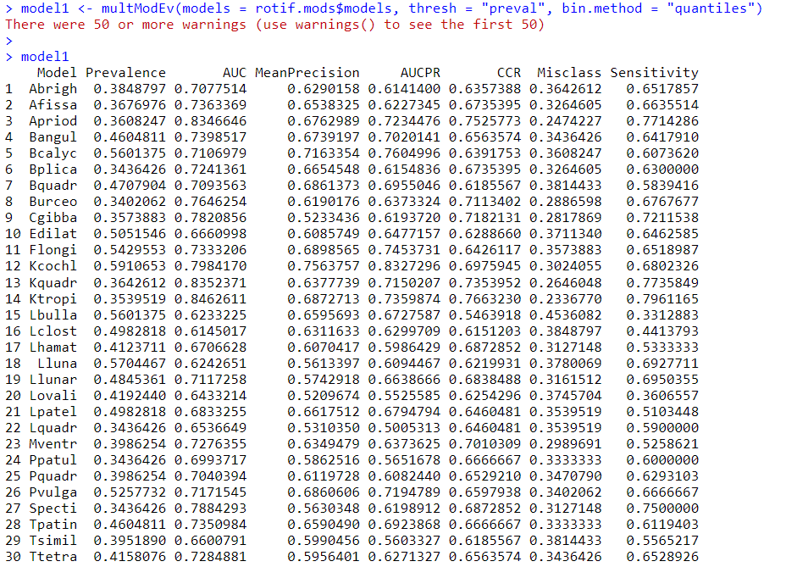 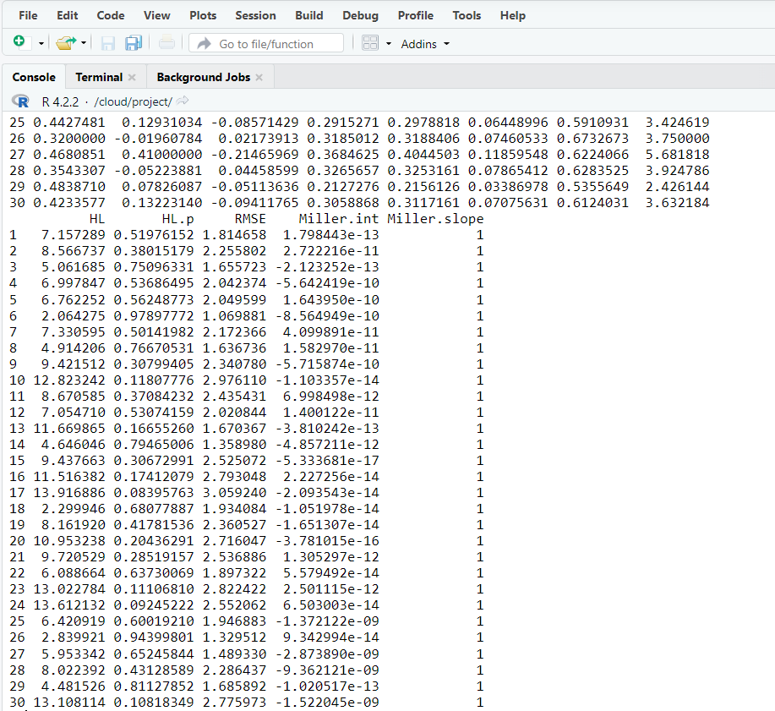

 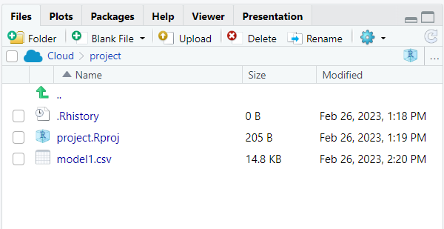

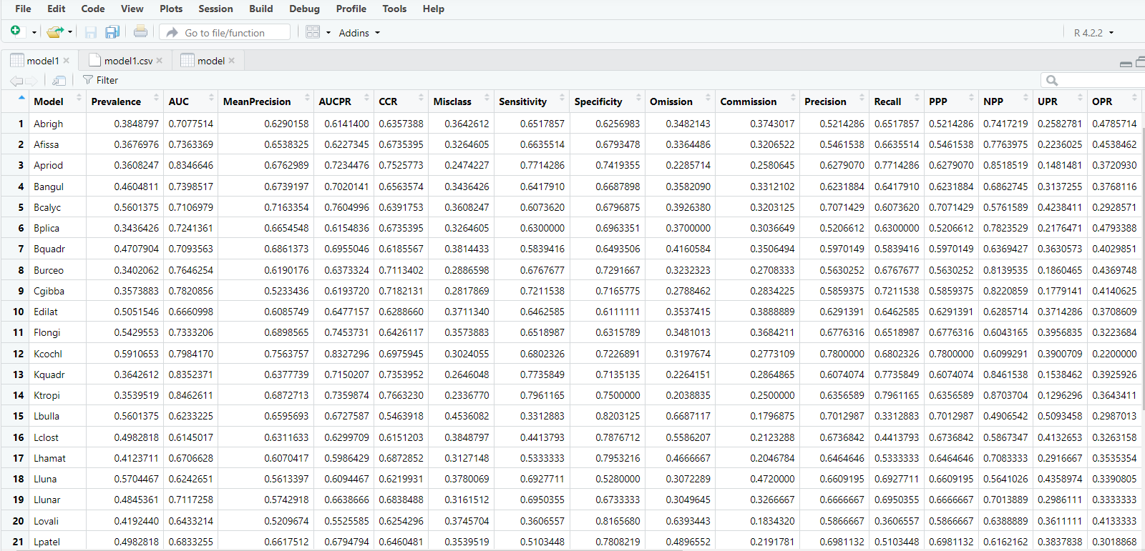

**Conclusion :** Data visualisation in R and RStudio makes it possible to easily use basic plotting functions, or apply more advanced functions through packages.As you must have noticed throughout this week, the undeniable **added value** of R/RStudio compared to the more classical resources such as **Excel**, is the ability to produce **publication-ready graphics**. For this, you can either use default functions and options, which already produce a highly controlled output quality, or you can also pre-define advanced options and use them in variables.